Event Attendance for [Master Event Name]
Thank you for your help checking people in to an event! Below are the instructions for using the scanners. If you are using your own device, skip down to #5.
- Power on the device
  - If the device is not already turned on, long press on the power button (either along the top edge of the device, or a red button by the keypad)
- From the bottom edge of the screen, swipe up to open to the Home screen
  - Ignore/close any alerts or windows that open automatically
- Make sure it’s connected to a network
  - If the device has a yellow highlighter mark along the side edges, it has cellular networking capabilities and doesn’t require connecting to a network
  - If you are connecting to WiFi, tap “WiFi Manager” on the Home screen
    - Find the [network name] network
    - Enter the password provided to you separately, OR
    - Wait for the captive portal to pop up (typical for many Guest networks) and follow the instructions to get connected
    - If the portal requires an email address and you were not given one separately, use sigops+####@alumniq.com, where the 4 digits match the number on the AlumnIQ sticker on the back of the device.
  - If you are connecting to a hotspot, tap “WiFi Manager” on the home screen
    - Find the [network name] network
    - Enter the password provided to you separately
- Login to Gatekeeper
  - Once connected, tap the “Gatekeeper” icon at the bottom of the Home screen
  - A dark blue screen with AlumnIQ logo will appear with a few buttons
  - Tap the first one labeled “I have an iqKey”
  - Use the device to scan the QR code provided to you (either printed or by email)
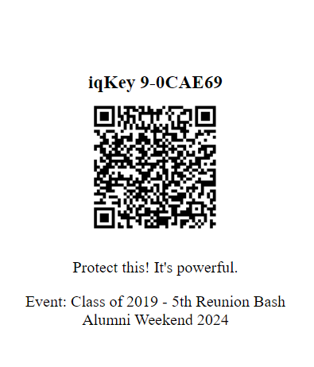
Printed iqKey
A card was printed for you and included in this packet for your use. It will list the event title. Keep it safe and put it back in the packet before returning.

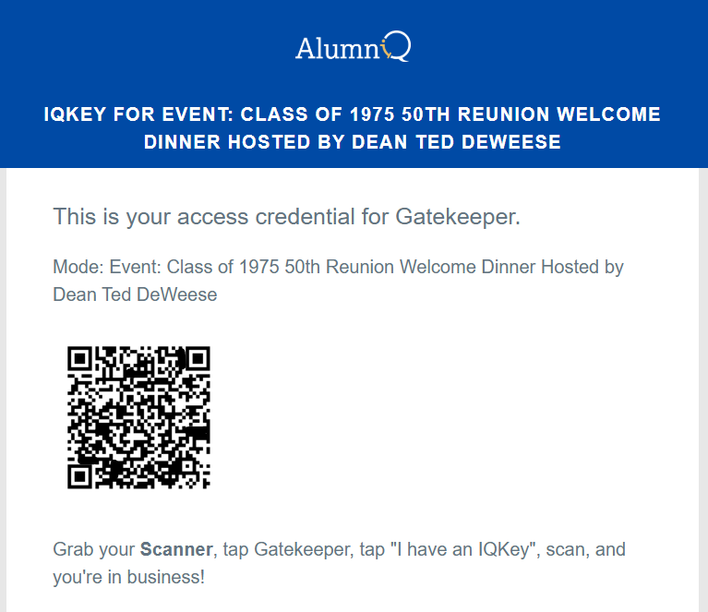
iqKey By Email
You received an email on [Date] from [email address] that looks like this:

To capture a scan, you have the option to use one of the buttons on each long edge of the device, or the one on the face of the device, just below the screen. All have a color border.
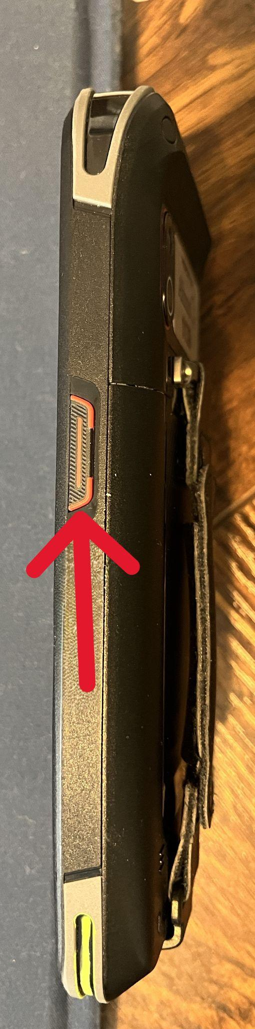
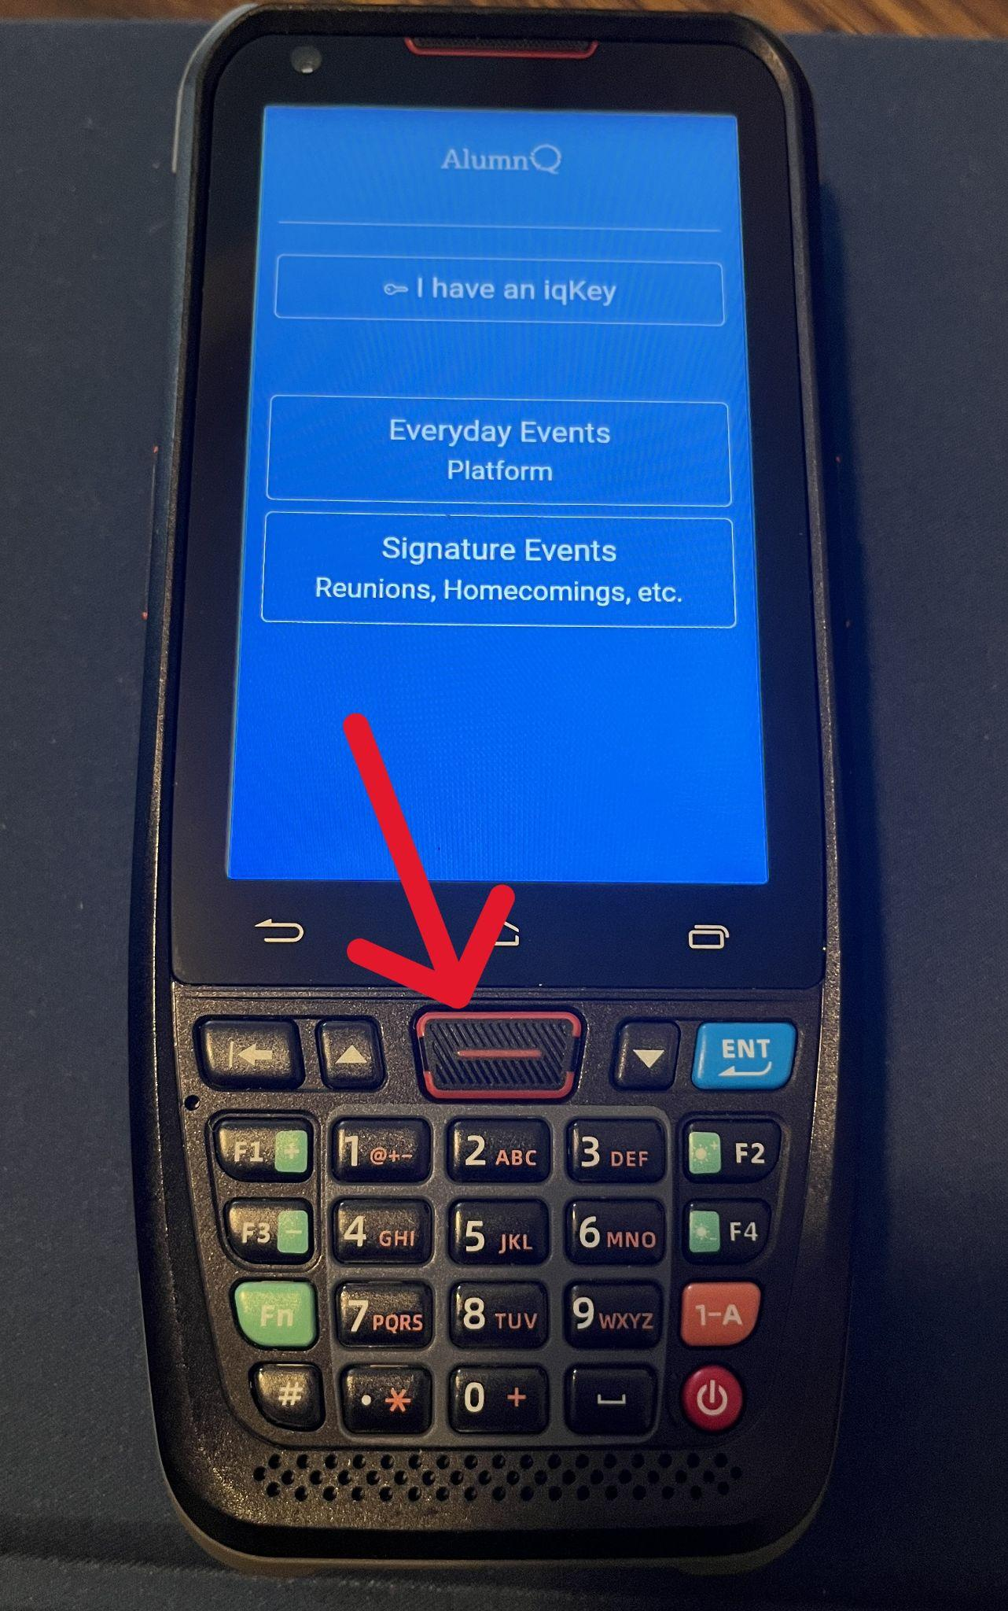

- Using your own device
  - If you are using your own phone or a tablet, first make sure you are connected.
  - Then open your camera and scan the QR code provided to you (either printed or by email)
  - You may need to give permission for the browser to use the camera
- Verify the event is correct
  - Once logged in, you will be taken directly to the check-in screen with the name of the event at the top.
  - If the event is not the correct one you are assigned to, tap the hamburger menu in the bottom right corner, and tap ‘Change Event.’
  - Scroll through the (chronological) list to find the correct event and tap to be taken to the check-in screen.
- Ready for scanning
  - Verify that the cursor is blinking in the input field in the bottom left corner. That means the scanner is ready to accept a scan.
  - Point the top edge of the scanner at the QR code and hold down one of the capture buttons until you hear a beep.
  - If using your own device, position the camera over the QR code to capture the scan.
  - Screen will show green or red to validate if the person is registered and paid.
- [Insert instructions here for what to do if the screen shows red, indicating the person should be denied entry.]

